Object Oriented Analysis and Design Patterns

A Report On

Singleton
&
Double Checked Locking

Design Patterns

By:
Abhilash K (1MS14IS135)
Salman R (1MS14IS092)

Singleton Design Pattern

Key Features:

- Intent:
  - Ensure a class has one instance and provide a global point of access to it.
- Problem:
  - Several different client objects need to refer to the same thing, and we want to ensure that we do not have more than one of them
- Solution:
  - Guarantee one instance
- Participants and Collaborator:
  - Clients create an instance of the Singleton solely through the getInstance() method
- Consequences:
  - Clients need not concern themselves whether an instance of the Singleton exists. This can be controlled from within the Singleton
- Implementation:
  - Add a private static member of the class that refers to the desired object (Initially it is null)
  - Add a public static method that instantiates this class if the member is null and then returns the value this member
  - Set the constructor’s status to protected or private so that no one can directly instantiate this class an bypass the static constructor mechanism

Generic Structure:

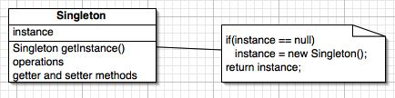

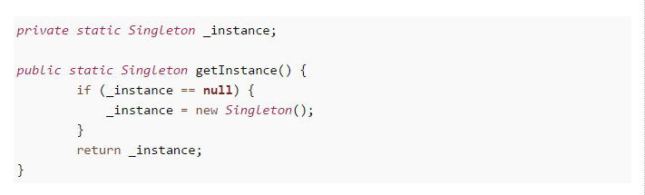
Implementation of Singleton’s getInstance() method:

Problem with this approach:

- Might lead to multiple instances of the Singleton object when getInstance() is called at the same time by multiple parallel threads
- When two calls to getInstace() are made by two threads at the same time:
  - First thread checks if instance exists. It does not, so it will create the first instance
  - Before it is done, second thread also checks if instance exists, it does not, so it will create the second instance
- Clients begin to use multiple instances individually as though they all refer to the same instance.
- If the class is stateless, then not a problem. Otherwise, changes in one object will not be reflected in all the other objects
  - If there is a connection, there will be two connections
  - If there is a counter, there will be two counters
- Thereby we lose the purpose of Singleton design pattern

A solution would be to make the entire method getInstance() synchronized
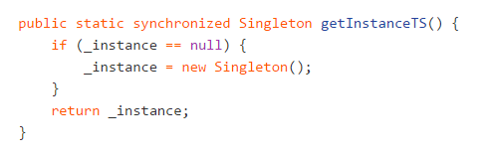

- Though it’s a thread-safe and solves issue of multiple instance, it's not very efficient.
- All the threads will have to wait for the check on whether the object already exists
- You need to bear cost of synchronization every time you call this method, while synchronization is only needed on first class, when Singleton instance is created.
- Thus, we avoid this approach and use an improvised method, called as Double Checked Locking (DCL)

Double Checked Locking (DCL)

- Only applies to multi-threaded applications
- Optimizes unnecessary locking
- Synchronization happens utmost one time, so it is not a bottleneck

Feature:
- Unnecessary locking is avoided by adding another test before creating the object

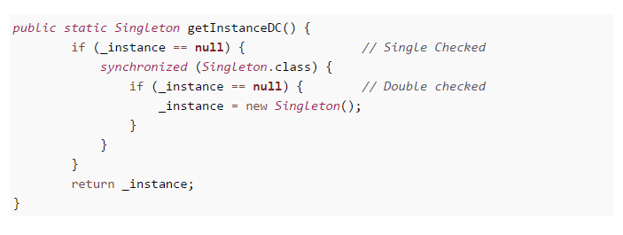
Implementation of DCL’s getInstance() method:

The solution is to do a sync after the test for null and then check again to make sure the instance member has not yet been created. Thus, it is called as Double Checked Locking
- Unnecessary locking is avoided by adding another test before creating the object
- On surface this method looks perfect, as you only need to pay price for synchronized block one time, but it still broken, until you make _instance variable volatile.
- Without volatile modifier it's possible for another thread in Java to see half initialized state of _instance variable, but with volatile variable guaranteeing happens-before relationship, all the write will happen on volatile _instance before any read of _instance variable.

DCL’s Actual Implementation:
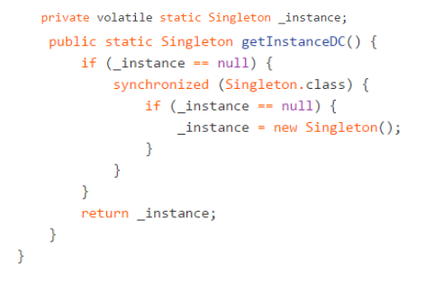

Example:

A print spooler is a software program responsible for managing all print jobs currently being sent to the printer or print server.

- It is obvious here that we do want want to maintain multiple print spooler and queues, which leads to duplicate entries and a lot of confusion.
- Thereby, we restrict ourselves to using only one instance of the print spooler.
- This is done by using Singleton and Double Checked Locking, since multiple users may try to access the print spooler at the same time

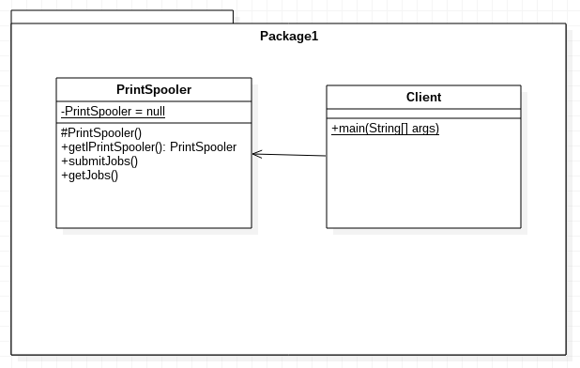

PrintSpooler.java

public class PrintSpooler {
private volatile static PrintSpooler b = null;
private ArrayList<Integer> jobs = new ArrayList();

private PrintSpooler(){
// empty constructor
}

public static PrintSpooler getPrintSpooler(){
if(b == null){
synchronized(PrintSpooler.class){
if(b == null)
b = new PrintSpooler();
}
}else{
System.out.println("PrintSpooler already initiallized. Returning existing instance");
}
return b;
}

public void submitJob(int jobId){
if(jobs != null){
jobs.add(jobId);
}
}

public void getjobs(){
System.out.println("PrintSpooler - submitted jobs are: ");
for (int job:jobs) {
System.out.println(job);
}
}

}
Client.java

public class Client {
public static void main(String[] args){
PrintSpooler spooler = PrintSpooler.getPrintSpooler();
spooler.submitJob(10);
spooler.submitJob(20);
spooler.submitJob(30);
spooler.getjobs();
PrintSpooler spooler2 = PrintSpooler.getPrintSpooler();
spooler2.submitJob(40);
spooler2.submitJob(50);
spooler2.submitJob(60);
spooler2.getjobs();
}
}
Output:

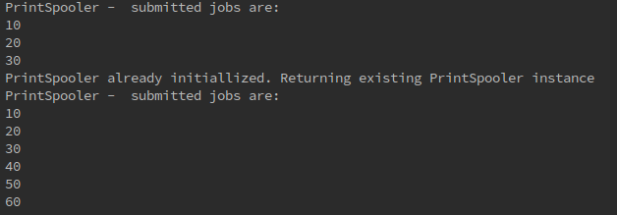

We see that, when we tried to obtain the spooler for the second time, the existing one was returned instead of re instantiating it.
spooler2.getJobs() returned all the jobs that were submitted to spooler1 as well since both of them essentially refer to same single instance that was created the first time

Conclusion:
Thus, we can ensure that even in multi-threaded applications, all the dependents will have only one instance and all of them will have a global point of access to read or modify it.

